**Week 4 Homework Submission File: Linux Systems Administration**

**Step 1: Ensure/Double Check Permissions on Sensitive Files**

1. Permissions on /etc/shadow should allow only root read and write access.
   * 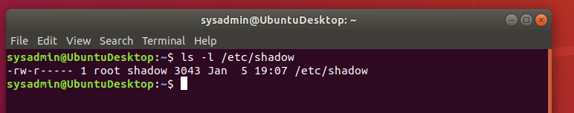Command to inspect permissions:
   * Command to set permissions (if needed): 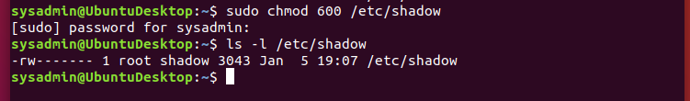 sudo chmod 600 /etc/shadow
2. Permissions on /etc/gshadow should allow only root read and write access.
   * 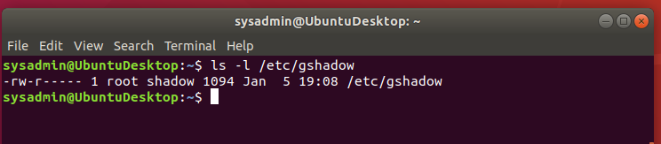Command to inspect permissions:
   * Command to set permissions (if needed): 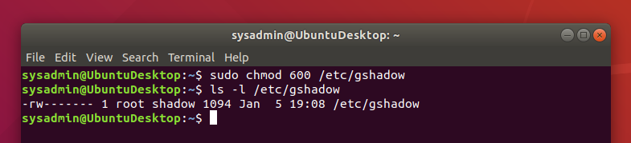sudo chmod 600 /etc/gshadow
3. Permissions on /etc/group should allow root read and write access, and allow everyone else read access only.
   * Command to inspect permissions: 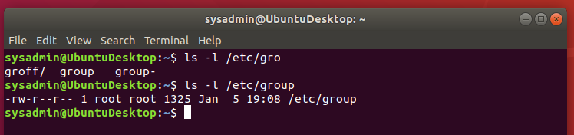
   * Command to set permissions (if needed): 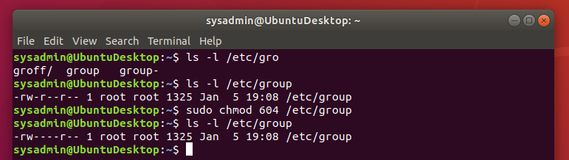 sudo chmod 604 /etc/group
4. Permissions on /etc/passwd should allow root read and write access, and allow everyone else read access only.
   * Command to inspect permissions: 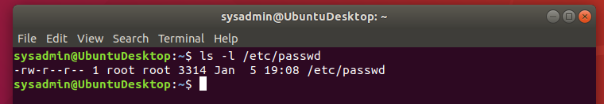
   * Command to set permissions (if needed): 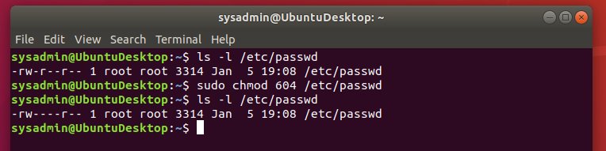sudo chmod 604 /etc/passwd

**Step 2: Create User Accounts**

1. Add user accounts for sam, joe, amy, sara, and admin.
   * Command to add each user account (include all five users):
   * sudo adduser sam
   * sudo adduser joe
   * sudo adduser amy
   * sudo adduser sara
   * sudo adduser admin
2. Ensure that only the admin has general sudo access.
   * Command to add admin to the sudo group: sudo usermod -aG sudo admin 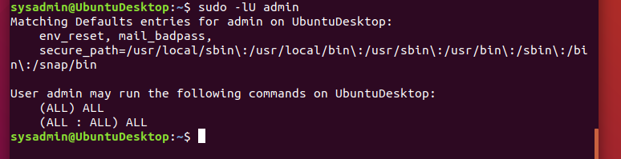

**Step 3: Create User Group and Collaborative Folder**

1. Add an engineers group to the system.
   * Command to add group: 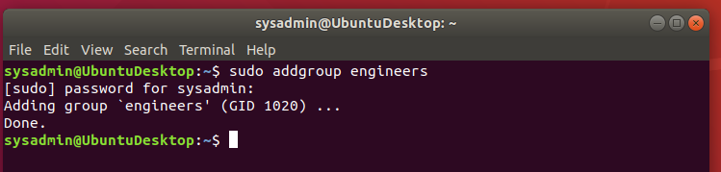 sudo addgroup engineers
2. Add users sam, joe, amy, and sara to the managed group.
   * Command to add users to engineers group (include all four users): 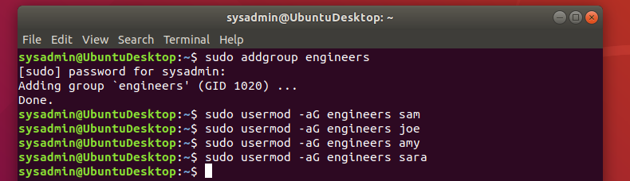
3. Create a shared folder for this group at /home/engineers.
   * Command to create the shared folder: 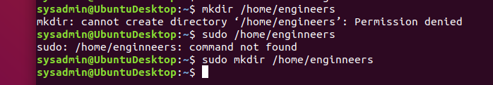
   * sudo mkdir /home/engineers
4. Change ownership on the new engineers' shared folder to the engineers group.
   * Command to change ownership of engineer's shared folder to engineer group: sudo chown root:engineers /home/engineers

**Step 4: Lynis Auditing**

1. Command to install Lynis: 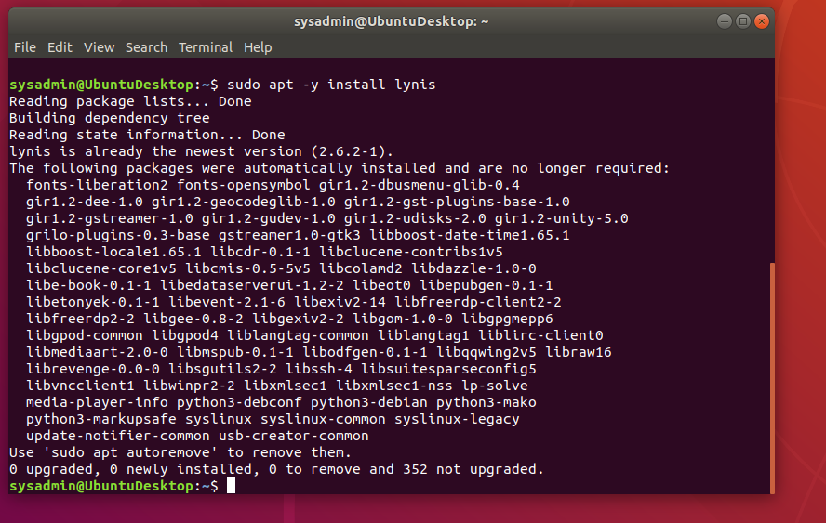 sudo apt -y install lynis
2. Command to see documentation and instructions: man lynis
3. Command to run an audit: sudo lynis audit system
4. Provide a report from the Lynis output on what can be done to harden the system.
   * Screenshot of report output: 